**JAVA SWING BASED**

**BMI BASED RECOMMENDATION SYSTEM**

**-SQL CONNECTIVITY USING JDBC**

*A*

*Report*

*Submitted in partial fulfilment of the*

*Requirements for the award of the Degree of*

***BACHELOR OF TECHNOLOGY***

***IN***

**INFORMATION TECHNOLOGY**

By

**ZOHA TABASSUM <1602-20-737-053>**

**Under the Guidance of**

**B. Leelavathy**



**Department of Information Technology****Vasavi College of Engineering (Autonomous)**

**(Affiliated to Osmania University)**

**Ibrahimbagh, Hyderabad-31**

**2021-2022**

# BONAFIDE CERTIFICATE

This to Certify that the project report titled

**“BMI BASED RECOMMENDATION SYSTEM”** project work of Ms. Zoha Tabassum bearing Roll.no:1602-20-737-053 who carried out this project under my supervision in the IV semester for the academic year 2021-2022.

*Signature*   *Signature*   *external examiner internal examiner*

ROLL NO: 1602-20-737-053

NAME: Zoha Tabassum [2]

**ABSTRACT:**

The body mass index (BMI) is the metric currently in use for defining anthropometric height/weight characteristics in adults and for categorizing them into groups. The common interpretation is that it represents an index of an individual’s fatness. The BMI also does not capture information on the mass of fat in different body sites. The latter is related not only to untoward health issues but to social issues as well. Lastly, current evidence indicates there is a wide range of BMIs over which mortality risk is modest, and this is age related.

**REQUIREMENT ANALYSIS:**

**LIST OF TABLES:**

* User
* BMI
* Admin
* Final Report

**LIST OF ATTRIBUTES WITH THEIR DOMAIN TYPES:**

**USER:**

* user_name varchar2(20)
* user_id number(5)
* user_gender varchar2(5)
* user_age number(5)
* user_height number(5)
* user_weight number(5)

**BMI:**

* admin_id number(5)
* first_name varchar2(20)
* last_name varchar2(20)
* email varchar2(50)
* password varchar2(5)
* user_name varchar2(20)

**ADMIN:**

* admin_id number(5)
* first_name varchar2(20)
* last_name varchar2(20)
* email varchar2(50)
* password varchar2(5)
* user_name varchar2(20)

**FINALREPORT:**

* create table Finalreport(
* user_id number(5),
* user_name varchar2(20),
* user_height number(5),
* user_weight number(5),
* msg varchar2(50));

**ER DIAGRAM:**

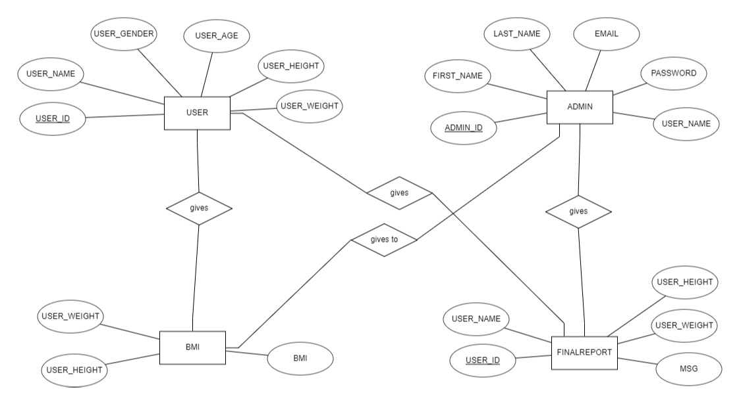

**RELATIONAL MODEL:**

**DDL OPERATIONS:**

**USERS:**

CREATE TABLE Users(

user_name varchar2(20),

user_id number(5),

user_gender varchar2(5),

user_age number(5),

user_height number(5),

user_weight number(5));

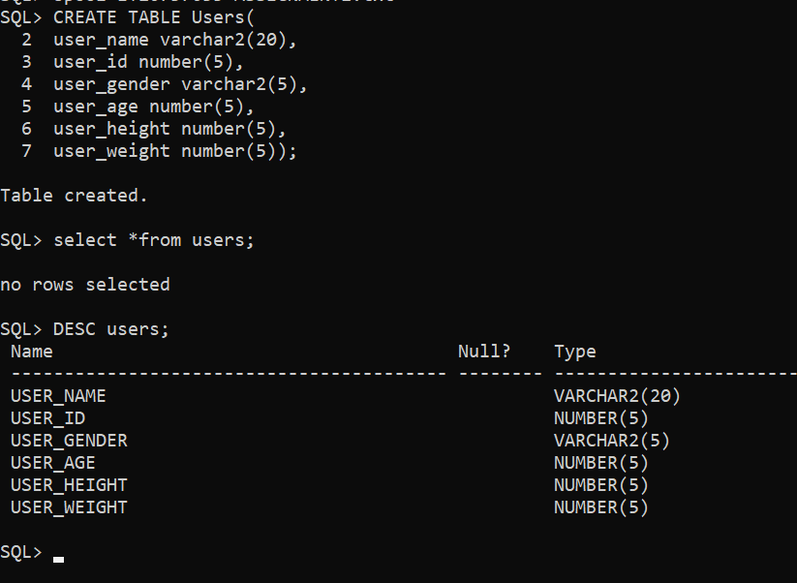

**SETTING USER_ID AS PRIMARY KEY:**

alter table users add primary key(user_id);

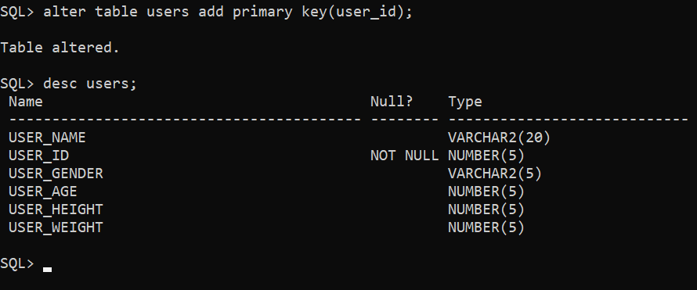

**BMI:**

create table BMI(

user_height number(5),

user_weight number(5),

bmi number(5));

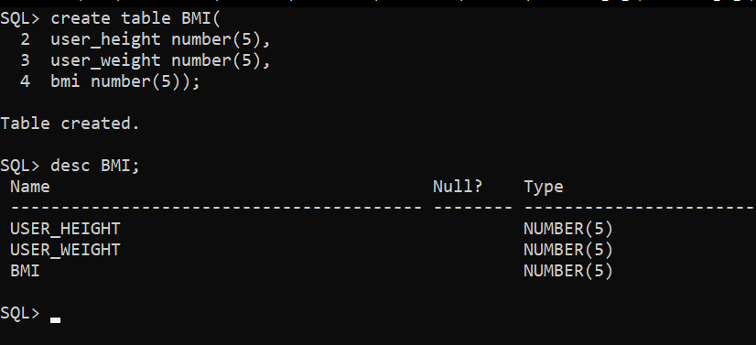

**ADMIN:**

create table Admin(

admin_id number(5),

first_name varchar2(20),

last_name varchar2(20),

email varchar2(50),

password varchar2(5),

user_name varchar2(20));

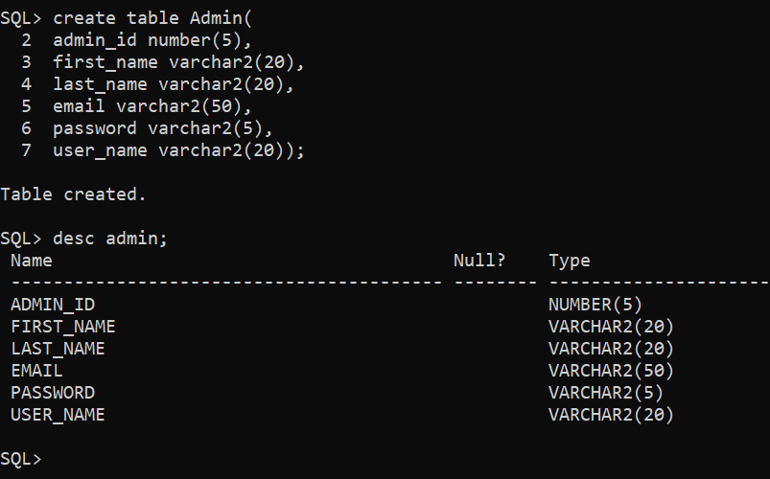

**SETTING ADMIN_ID AS PRIMARY KEY:**

alter table Admin add primary key(admin_id);

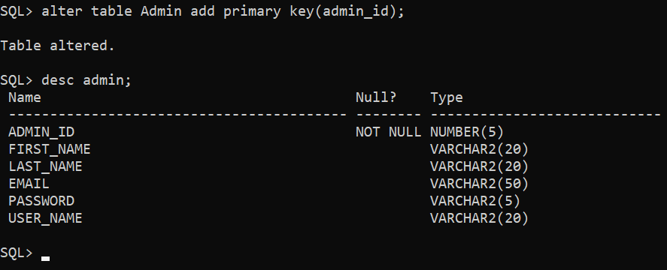

**FINAL REPORT:**

create table Finalreport(

user_id number(5),

user_name varchar2(20),

user_height number(5),

user_weight number(5),

msg varchar2(50));

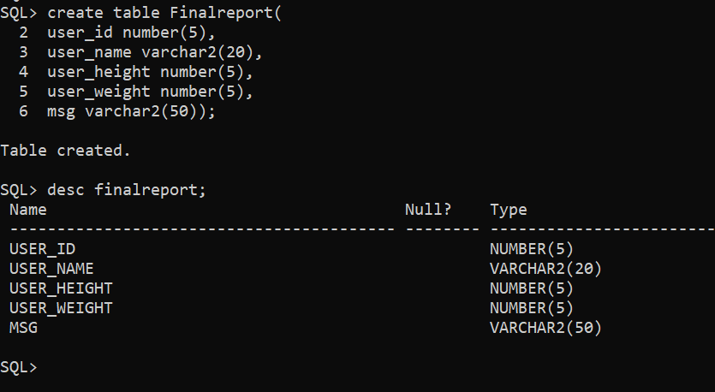

**Making user_id as foreign key:**

Alter table finalreport add foreign key(user_id) references users;

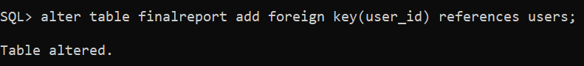

**DML OPERATIONS:**

**USERS:**

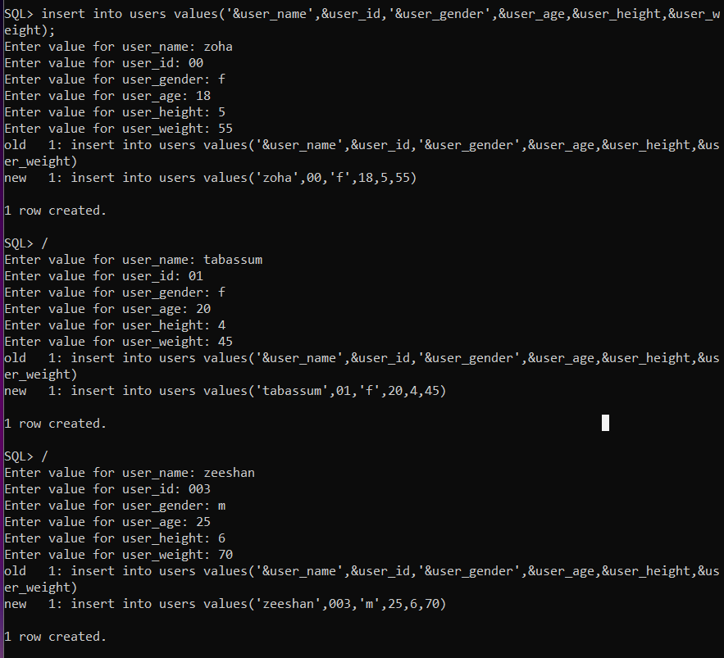

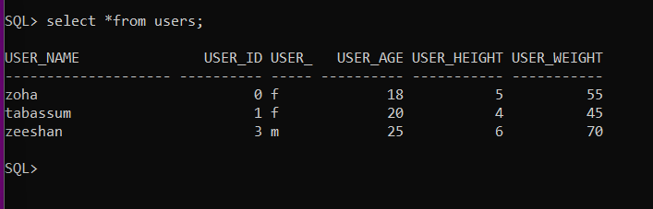

**BMI:**

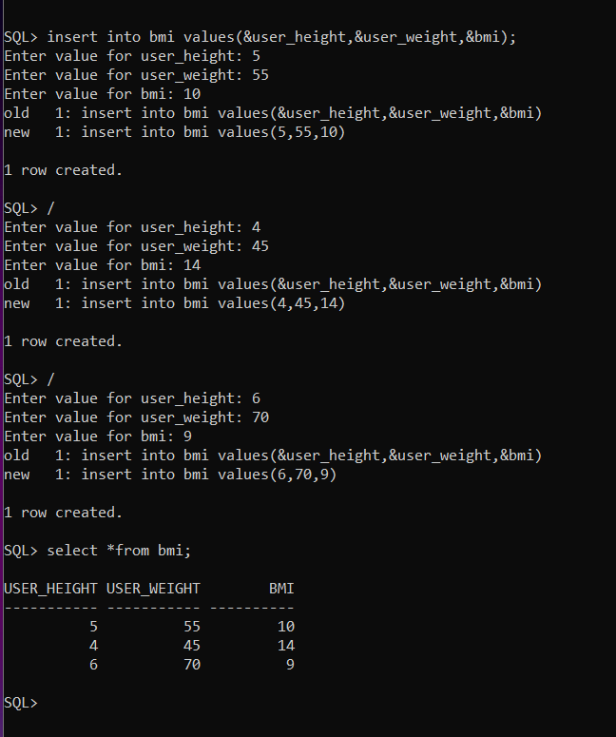

**ADMIN:**

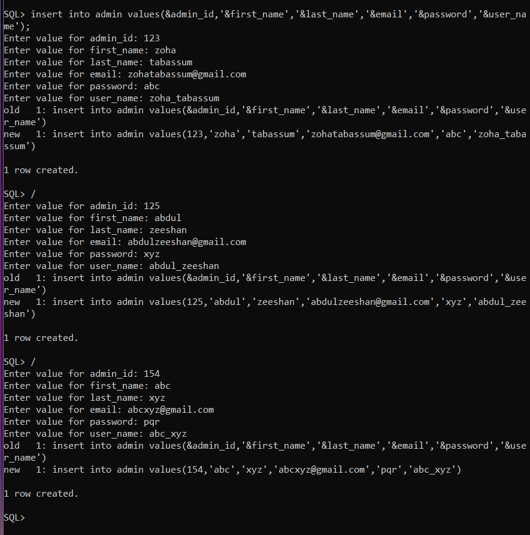

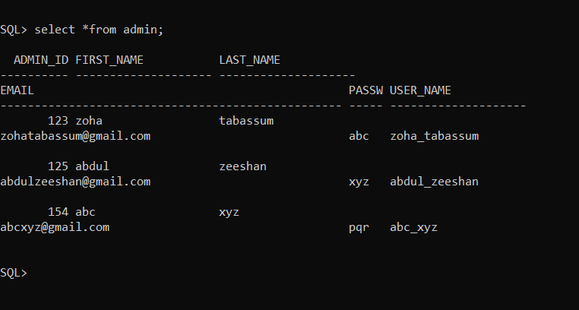

**FINAL REPORT:**

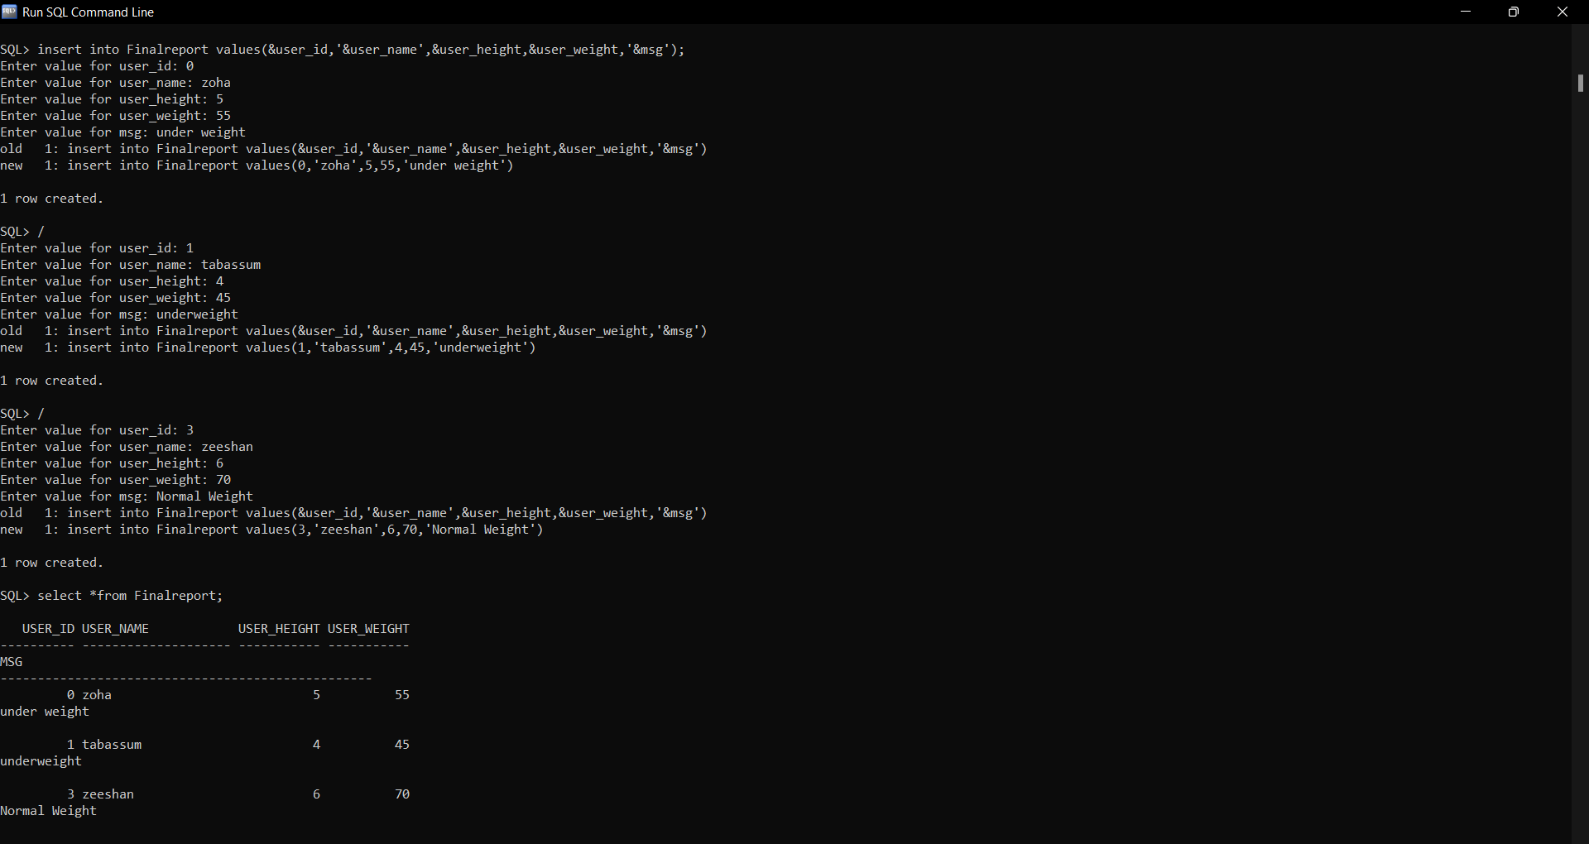

**Implementation:**

Front end programs and its connectivity Java Database Connectivity (JDBC) is an application programming interface (API) for the programming language Java, which defines how a client may access a database. It is a Java-based data access technology used for Java database connectivity. It is part of the Java Standard Edition platform, from Oracle Corporation. It provides methods to query and update data in a database and is oriented towards relational databases. The connection to the database can be performed using Java programming (JDBC API) as:

import java.sql.*;

public class TrialConnect{

public static void main(String[] args){

try{

Class.forName("oracle.jdbc.OracleDriver");

Connection con=DriverManager.getConnection("jdbc:oracle:thin:@localhost:1521:xe","zoha","zoha");

Statement stmt=con.createStatement();

ResultSet rs=stmt.executeQuery("select * from USERS");

while(rs.next())

System.out.println(rs.getString(1)+" "+rs.getString(2)+" "+rs.getString(3));

con.close();

}

catch(Exception e){

System.out.println(e);

}

}

}

Thus, the connection from Java to Oracle database is performed and therefore, can be used for updating tables in the database directly.

**PROGRAM:**

import javax.swing.*;

class UserUI

{

JTextField t1,t2,t3,t4,t5,t6;

JLabel l1,l2,l3,l4,l5,l6;

JPanel p;

public UserUI()

{

createComponents();

addComponents();

}

void createComponents()

{

t1 = new JTextField();

t1.setBounds(250,20,200,30);

t2 = new JTextField();

t2.setBounds(250,80,200,30);

t3 = new JTextField();

t3.setBounds(250,140,200,30);

t4 = new JTextField();

t4.setBounds(250,200,200,30);

t5 = new JTextField();

t5.setBounds(250,260,200,30);

t6 = new JTextField();

t6.setBounds(250,320,200,30);

l1 = new JLabel("User Name : ");

l1.setBounds(100,20,100,30);

l2 = new JLabel("User Id : ");

l2.setBounds(100,80,100,30);

l3 = new JLabel("Gender : ");

l3.setBounds(100,140,100,30);

l4 = new JLabel("Age : ");

l4.setBounds(100,200,100,30);

l5 = new JLabel("Height(cm) : ");

l5.setBounds(100,260,100,30);

l6 = new JLabel("Weight(kg) : ");

l6.setBounds(100,320,100,30);

p = new JPanel(null);

p.setBounds(0,0,600,400);

}

void addComponents()

{

p.add(l1);

p.add(t1);

p.add(l2);

p.add(t2);

p.add(l3);

p.add(t3);

p.add(l4);

p.add(t4);

p.add(l5);

p.add(t5);

p.add(l6);

p.add(t6);

}

}

**ADMIN:**

import javax.swing.*;

class AdminUI

{

JTextField t1,t2,t3,t4,t5,t6;

JLabel l1,l2,l3,l4,l5,l6;

JPanel p;

public AdminUI()

{

createComponents();

addComponents();

}

void createComponents()

{

t1 = new JTextField();

t1.setBounds(250,20,200,30);

t2 = new JTextField();

t2.setBounds(250,80,200,30);

t3 = new JTextField();

t3.setBounds(250,140,200,30);

t4 = new JTextField();

t4.setBounds(250,200,200,30);

t5 = new JTextField();

t5.setBounds(250,260,200,30);

t6 = new JTextField();

t6.setBounds(250,320,200,30);

l1 = new JLabel("Admin Id : ");

l1.setBounds(100,20,100,30);

l2 = new JLabel("First name: ");

l2.setBounds(100,80,100,30);

l3 = new JLabel("Last name : ");

l3.setBounds(100,140,100,30);

l4 = new JLabel("Email : ");

l4.setBounds(100,200,100,30);

l5 = new JLabel("Password : ");

l5.setBounds(100,260,100,30);

l6 = new JLabel("user name : ");

l6.setBounds(100,320,100,30);

p = new JPanel(null);

p.setBounds(0,0,600,400);

}

void addComponents()

{

p.add(l1);

p.add(t1);

p.add(l2);

p.add(t2);

p.add(l3);

p.add(t3);

p.add(l4);

p.add(t4);

p.add(l5);

p.add(t5);

p.add(l6);

p.add(t6);

}

}

**BMI:**

import javax.swing.*;

class BmiUI

{

JTextField t1,t2,t3;

JLabel l1,l2,l3;

JPanel p;

public BmiUI()

{

createComponents();

addComponents();

}

void createComponents()

{

t1 = new JTextField();

t1.setBounds(250,20,200,30);

t2 = new JTextField();

t2.setBounds(250,80,200,30);

t3 = new JTextField();

t3.setBounds(250,140,200,30);

l1 = new JLabel("User Height : ");

l1.setBounds(100,20,100,30);

l2 = new JLabel("User Weight : ");

l2.setBounds(100,80,100,30);

l3 = new JLabel("BMI : ");

l3.setBounds(100,140,100,30);

p = new JPanel(null);

p.setBounds(0,0,600,400);

}

void addComponents()

{

p.add(l1);

p.add(t1);

p.add(l2);

p.add(t2);

p.add(l3);

p.add(t3);

}

}

**FINAL REPORT:**

import javax.swing.*;

class Final_ReportUI

{

JTextField t1,t2,t3,t4,t5,t6;

JLabel l1,l2,l3,l4,l5,l6;

JPanel p;

public Final_ReportUI()

{

createComponents();

addComponents();

}

void createComponents()

{

t1 = new JTextField();

t1.setBounds(250,20,200,30);

t2 = new JTextField();

t2.setBounds(250,80,200,30);

t3 = new JTextField();

t3.setBounds(250,140,200,30);

t4 = new JTextField();

t4.setBounds(250,200,200,30);

t5 = new JTextField();

t5.setBounds(250,260,200,30);

l1 = new JLabel("User Name : ");

l1.setBounds(100,20,100,30);

l2 = new JLabel("User Id : ");

l2.setBounds(100,80,100,30);

l3 = new JLabel("User Height : ");

l3.setBounds(100,140,100,30);

l4 = new JLabel("User Weight : ");

l4.setBounds(100,200,100,30);

l5 = new JLabel("Message : ");

l5.setBounds(100,260,100,30);

p = new JPanel(null);

p.setBounds(0,0,600,400);

}

void addComponents()

{

p.add(l1);

p.add(t1);

p.add(l2);

p.add(t2);

p.add(l3);

p.add(t3);

p.add(l4);

p.add(t4);

p.add(l5);

p.add(t5);

}

}

**MAIN:**

import java.awt.*;

import java.awt.event.*;

import javax.swing.*;

class MainUIZ extends JFrame implements ActionListener

{

UserUI ob1;

BmiUI ob2;

AdminUI ob3;

Final_ReportUI ob4;

JButton submit,modify,delete,m1,m2,m3,m4;

JPanel p1,p2,p3,p4,pb;

JMenuBar mb;

public MainUIZ()

{

setSize(600,550);

setLayout(null);

setVisible(true);

setTitle("Body Mass Index");

ob1 = new UserUI();

ob2 = new BmiUI();

ob3 = new AdminUI();

ob4 = new Final_ReportUI();

createPanels();

createMenu();

createButtons();

addComponents();

setDefaultCloseOperation(JFrame.EXIT_ON_CLOSE);

}

void createPanels()

{

p1 = ob1.p;

p2 = ob2.p;

p3 = ob3.p;

p4 = ob4.p;

pb = new JPanel(new FlowLayout(FlowLayout.CENTER,50,0));

pb.setBounds(0,400,600,150);

}

void createMenu()

{

mb = new JMenuBar();

m1 = new JButton("User");

m1.setFocusable(false);

m2 = new JButton("Bmi");

m2.setFocusable(false);

m3 = new JButton("Admin");

m3.setFocusable(false);

m4 = new JButton("Final_Report");

m4.setFocusable(false);

m1.addActionListener(this);

m2.addActionListener(this);

m3.addActionListener(this);

m4.addActionListener(this);

mb.add(m1);

mb.add(m2);

mb.add(m3);

mb.add(m4);

}

public void actionPerformed(ActionEvent e)

{

remove(p1);

remove(p2);

remove(p3);

remove(p4);

if(e.getSource()==m1)

add(p1);

else if(e.getSource()==m2)

add(p2);

else if(e.getSource()==m3)

add(p3);

else

add(p4);

}

void createButtons()

{

submit = new JButton("Submit");

submit.addActionListener(new ActionListener()

{

public void actionPerformed(ActionEvent e)

{

JOptionPane.showMessageDialog(new JFrame(),"Successfully Inserted!","NOTICE",JOptionPane.INFORMATION_MESSAGE);

}

});

modify = new JButton("Modify");

modify.addActionListener(new ActionListener()

{

public void actionPerformed(ActionEvent e)

{

JOptionPane.showMessageDialog(new JFrame(),"Successfully Modified!","NOTICE",JOptionPane.INFORMATION_MESSAGE);

}

});

delete = new JButton("Delete");

delete.addActionListener(new ActionListener()

{

public void actionPerformed(ActionEvent e)

{

JOptionPane.showMessageDialog(new JFrame(),"Successfully Deleted!","NOTICE",JOptionPane.INFORMATION_MESSAGE);

}

});

pb.add(submit);

pb.add(modify);

pb.add(delete);

}

void addComponents()

{

add(p1);

add(pb);

setJMenuBar(mb);

}

public static void main(String a[])

{

new MainUIZ();

}

}

**FOLDER STRUCTURE:**

**Testing:**

**USERS:**

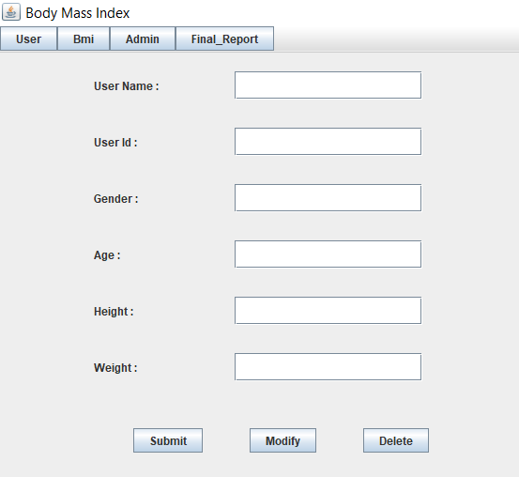

SUBMIT:

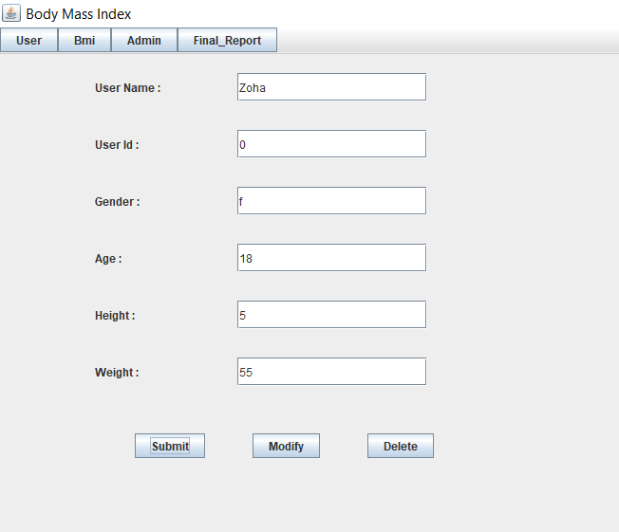

MODIFY:

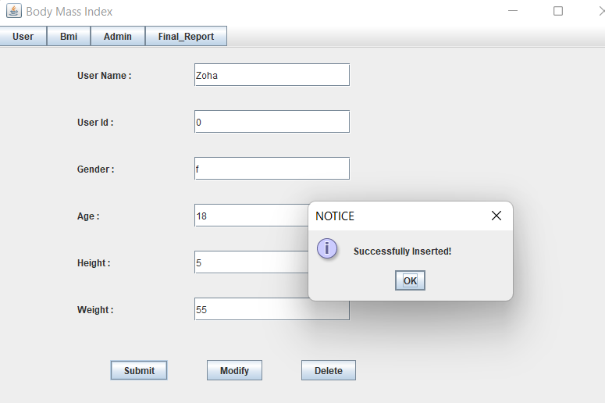

DELETE:

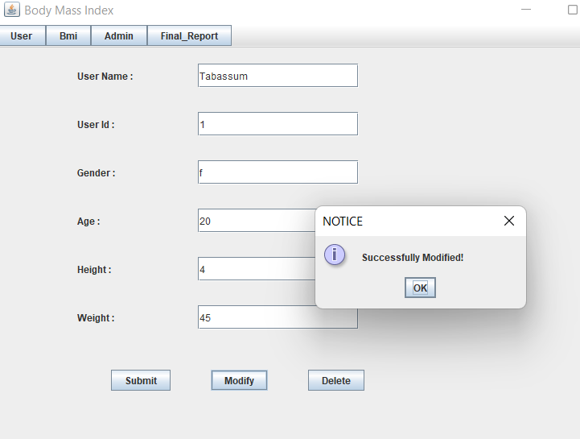

DELETE:

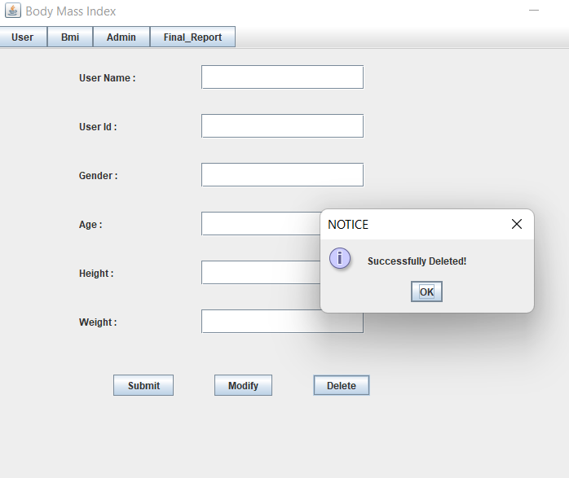

**BMI:**

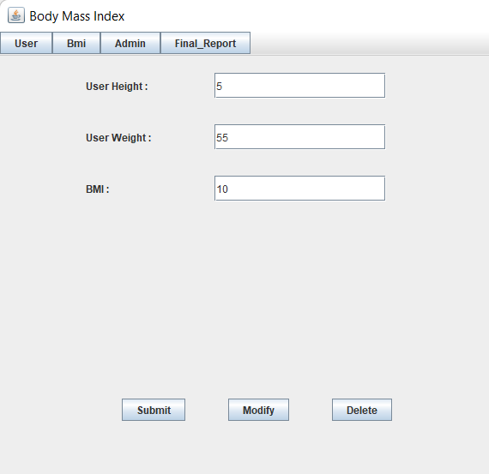

**ADMIN:**

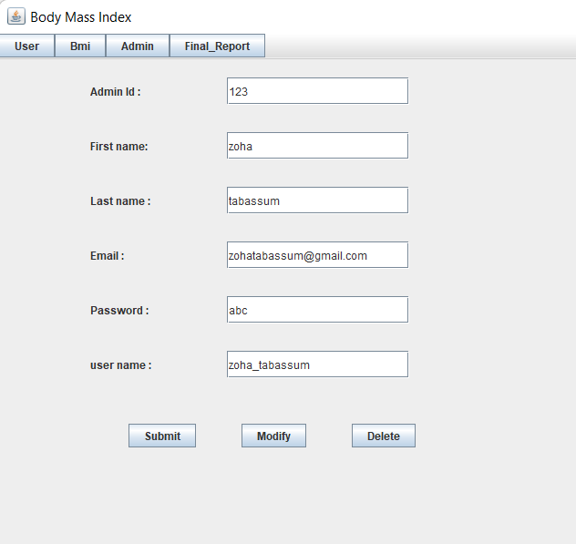

**FINAL REPORT:**

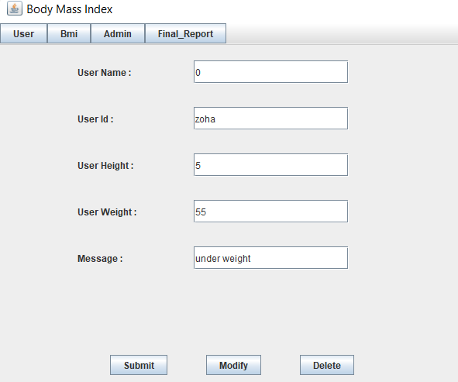

**Results:** I had successfully completed PROJECT on “BMI BASED RECOMMENDATION SYSTEM”

**LINKS:**

**https://github.com/Zoha-Tabassum/BMI**

**Discussion and future Work:**

This application provides the User to know about his body condition. In this application, it stores the information of a user and calculate their body mass index based on it, it tells the users body condition.

**CONCLUSION:**

Thus, a Java SWING based ***BMI BASED RECOMMENDATION SYSTEM*** is created which is connected to the Oracle 11g database. Therefore, all the entries and details are directly updated on their respective tables created in the database